AN INTERACTIVE RESUME

A “Resume”, but not at all like the normal ones, because of its interactive and dynamic nature. It has got loads of attractive links, good looking image slideshows and, last but not the least a “Chatbot”, which makes the site credible to be named as “An Interactive Resume”.

Link -

https://aninteractiveresume1.netlify.app/

Screenshots –

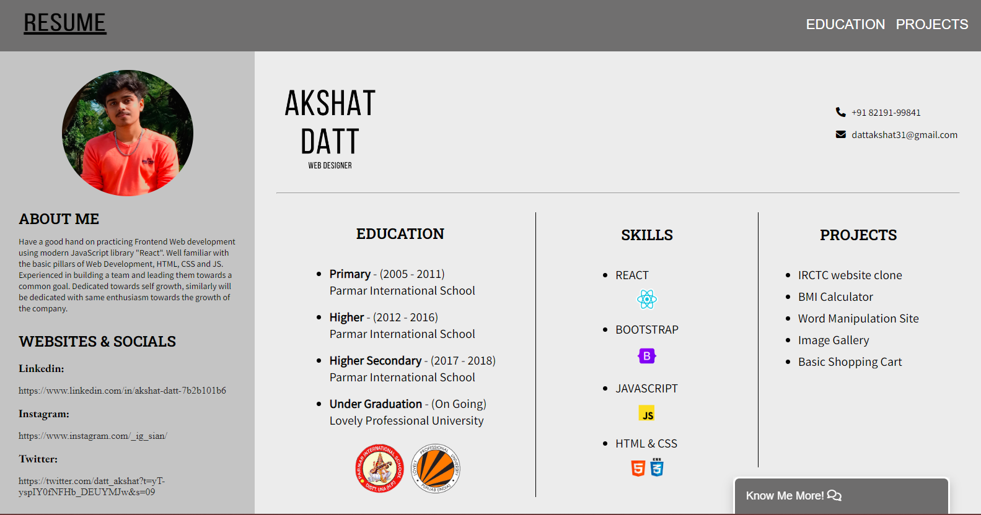

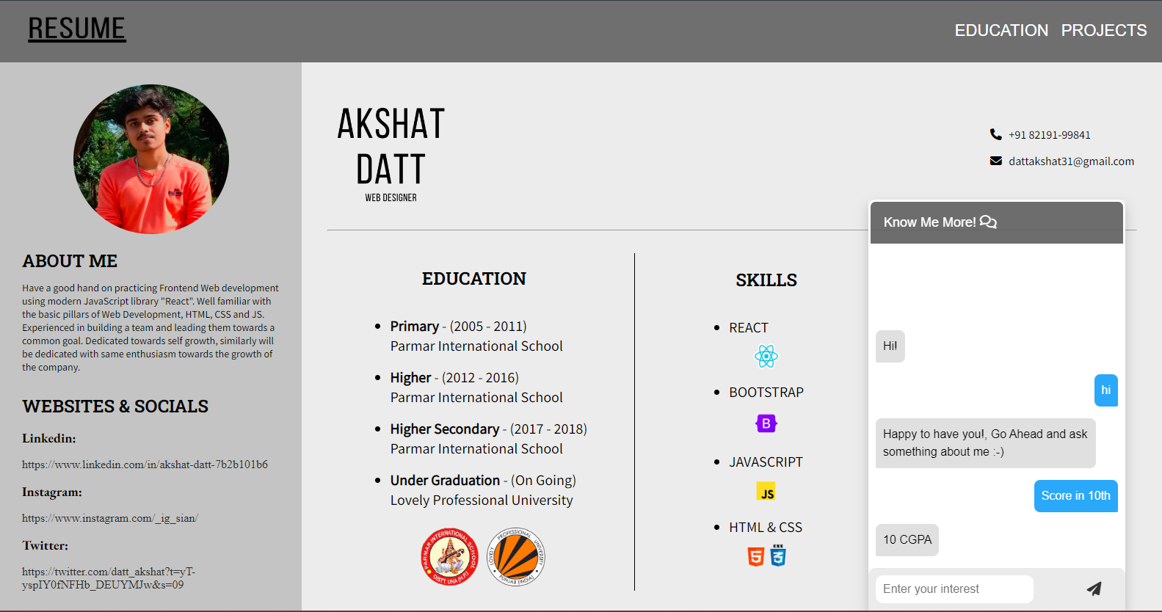

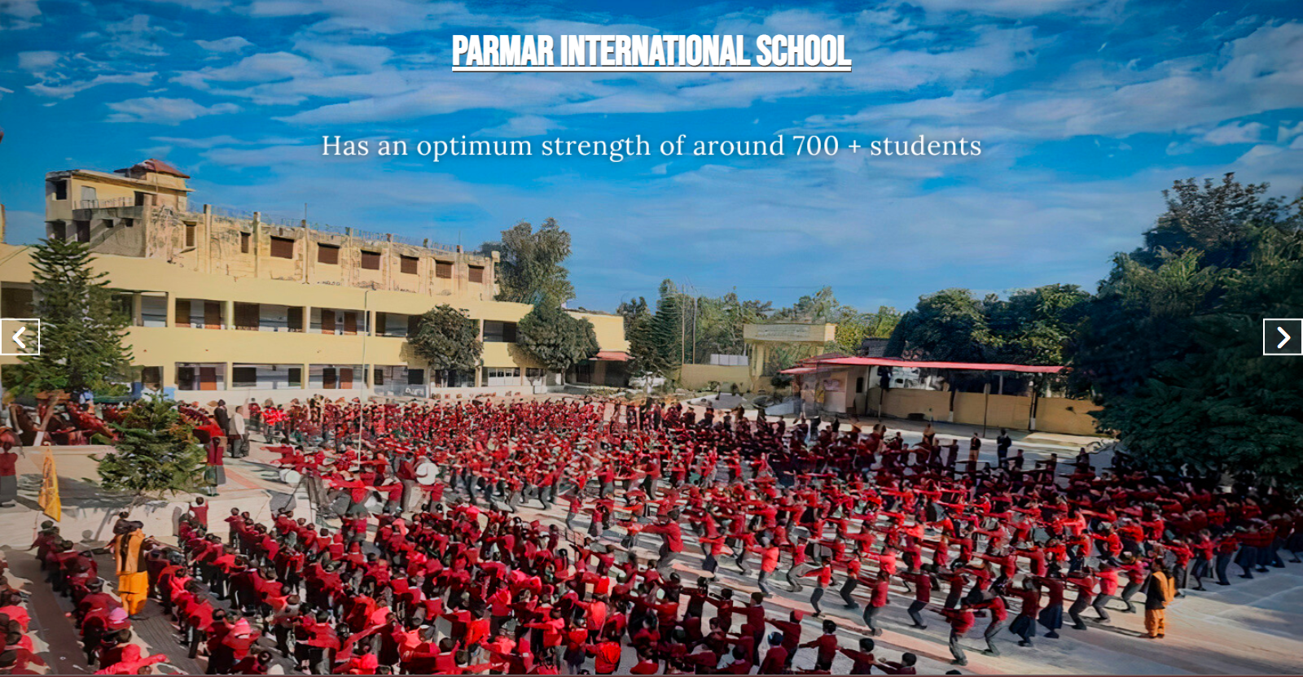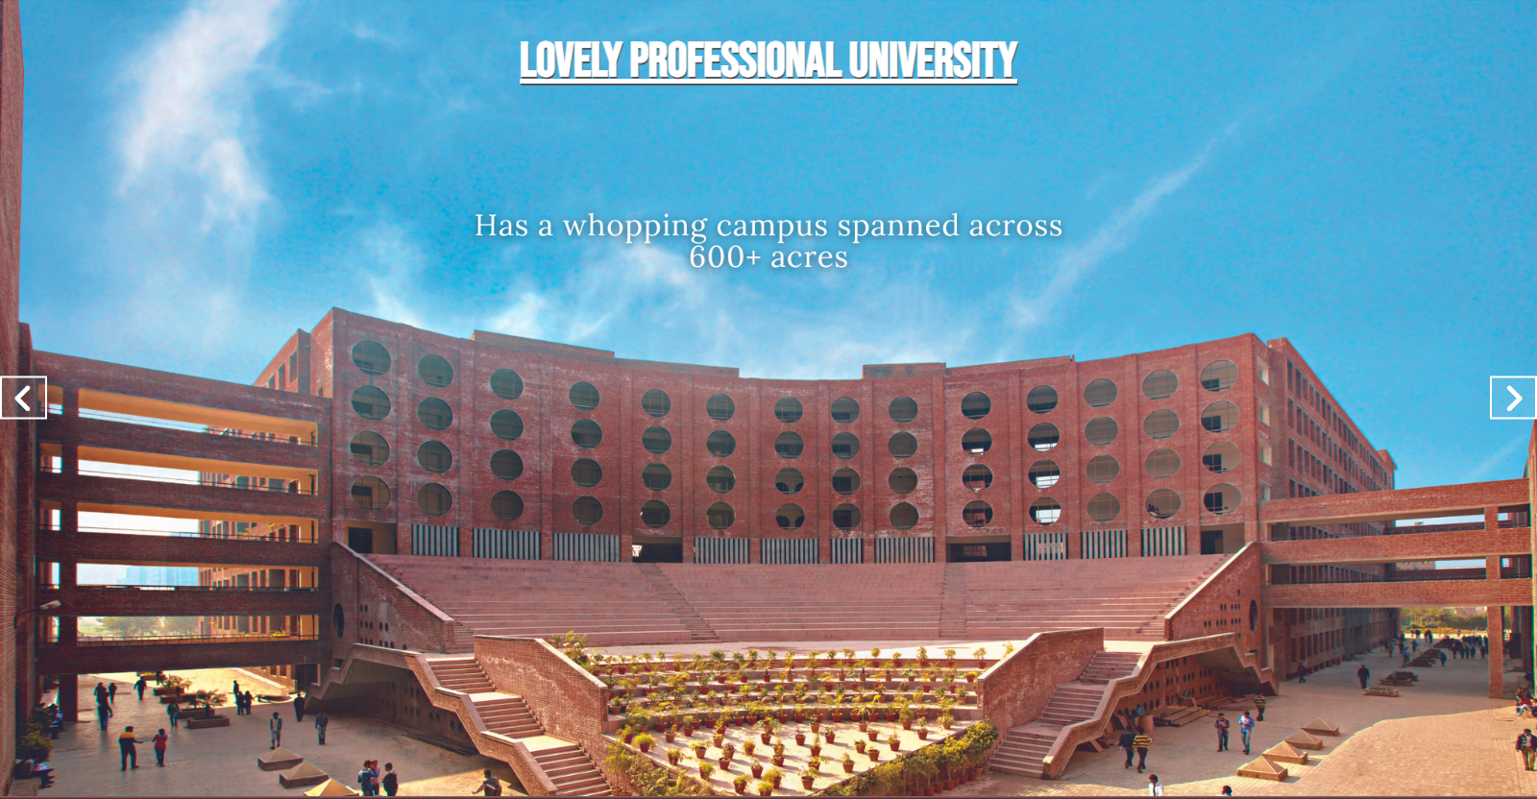

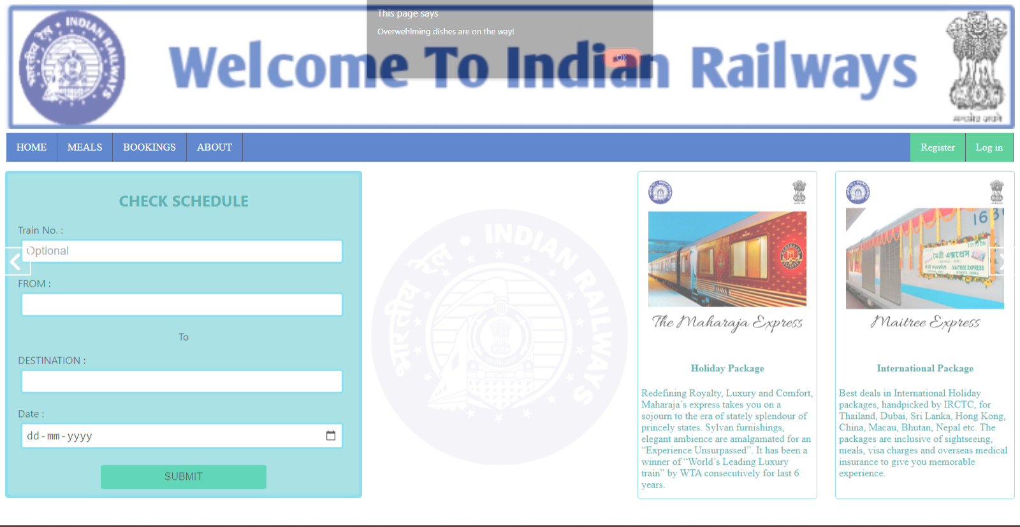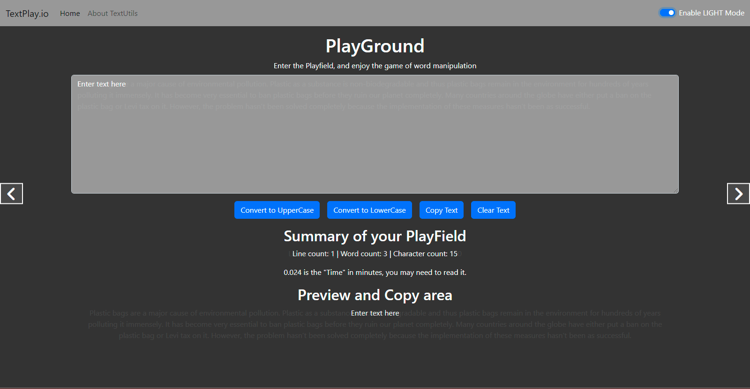

Technologies Used –

* HTML
* CSS
* JavaScript
* jQuery